Appendix -1
Snap shots of Project Team at Work/Results

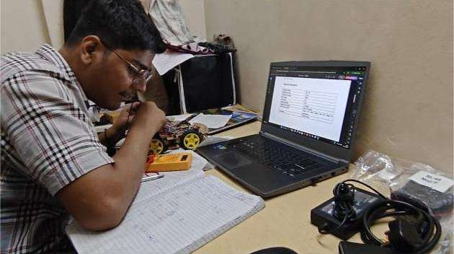
Figure 2.1 Team Leader (Ketan Sunil Rakhe)

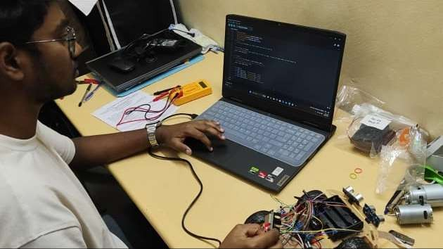
Figure 2.2 Member 1 (Krish Rajesh Tagram)

Department of E&TC Engineering DEC-2025

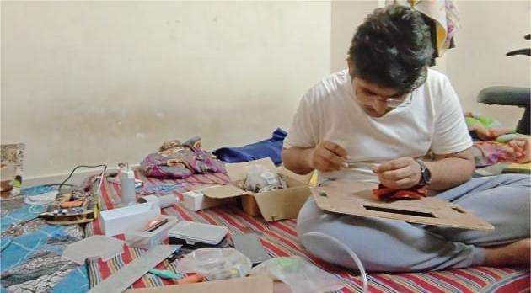
Figure 2.3 Member 2 (Rushikesh Rahul Chavhan)

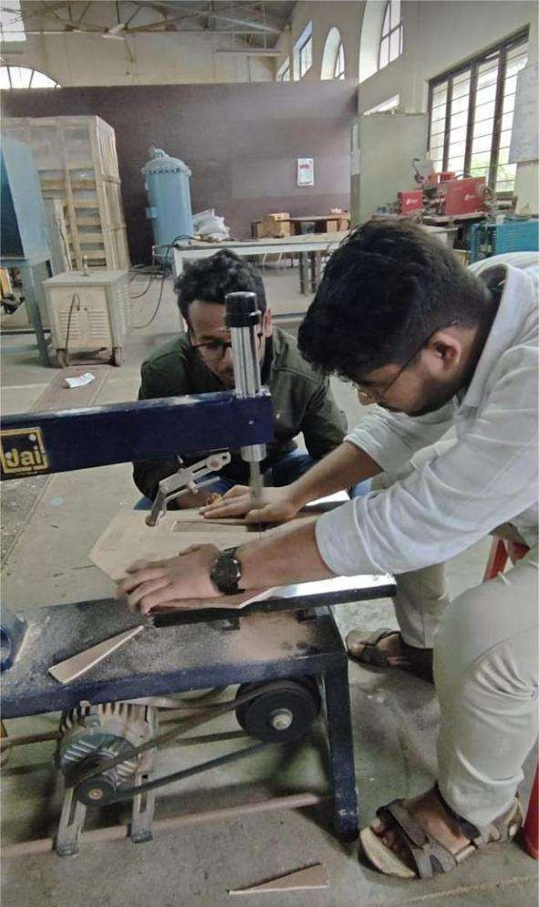
Figure 2.4 Member 2 (Rushikesh Rahul Chavhan)

- Mechanical Design Snapshots
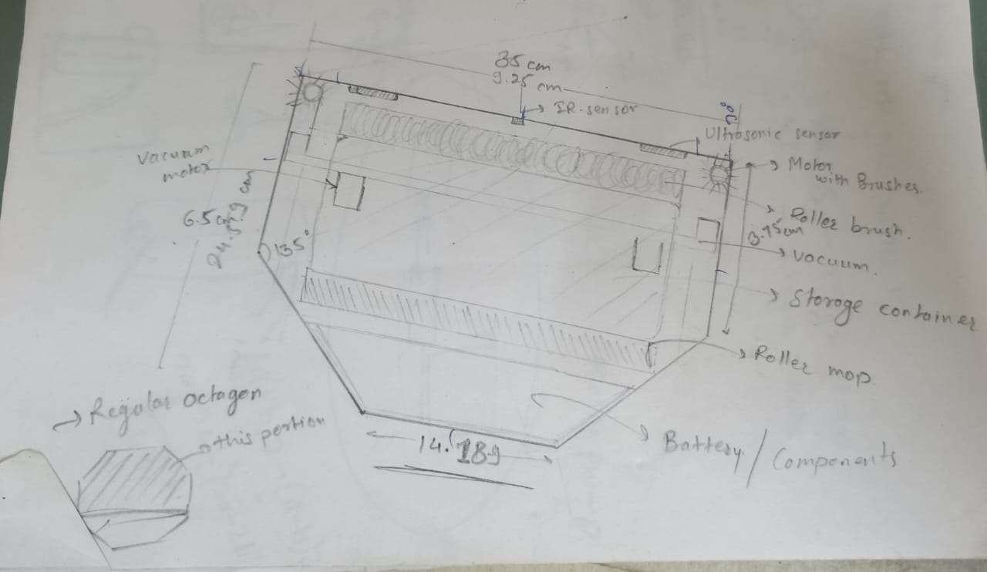
Figure 3.1 Skecth of HexaBot 1

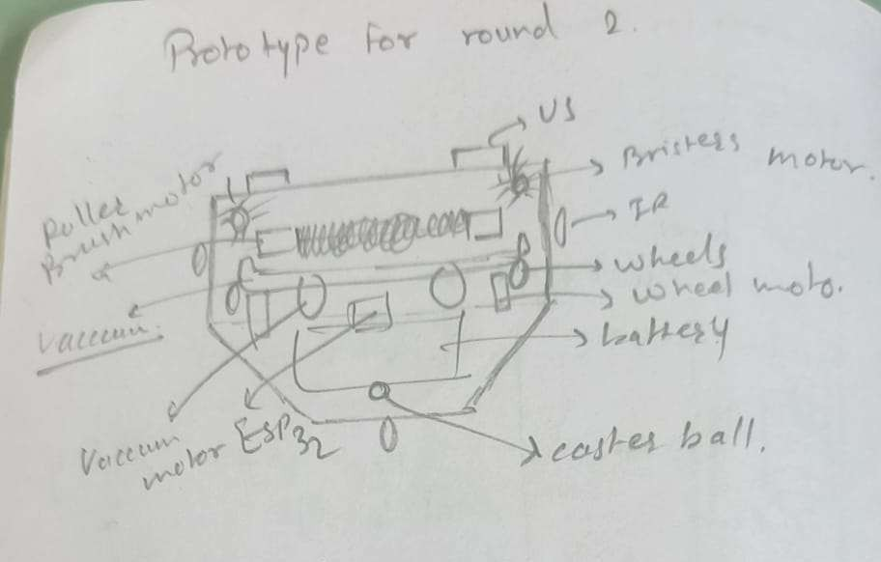
Figure 3.2 Skecth of HexaBot 2

Department of E&TC Engineering DEC-2025
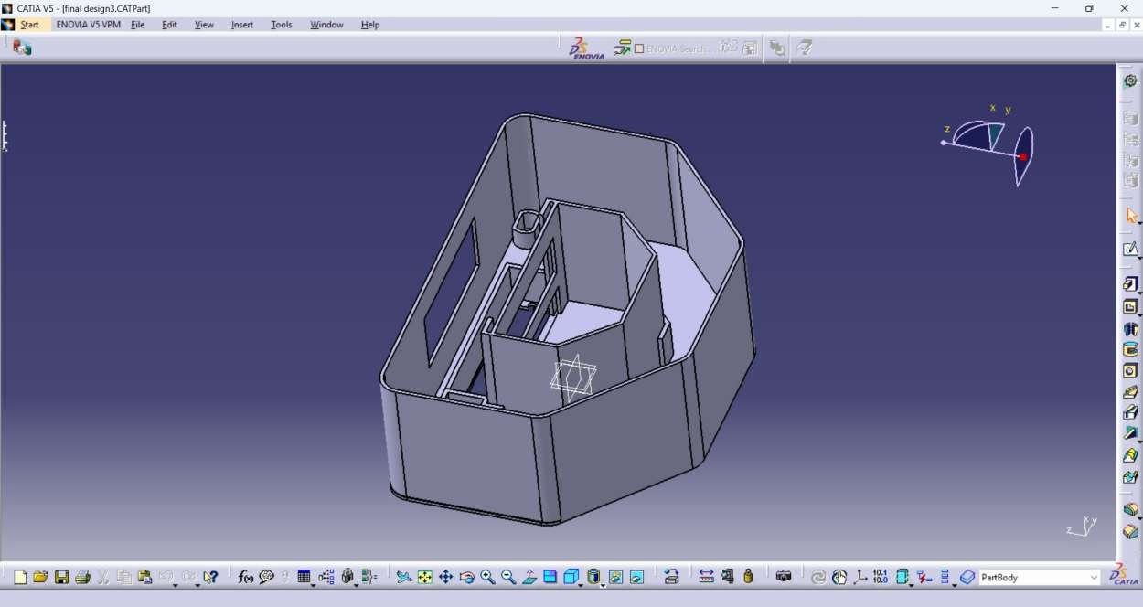
Figure 4.1 CAD Model of HexaBot

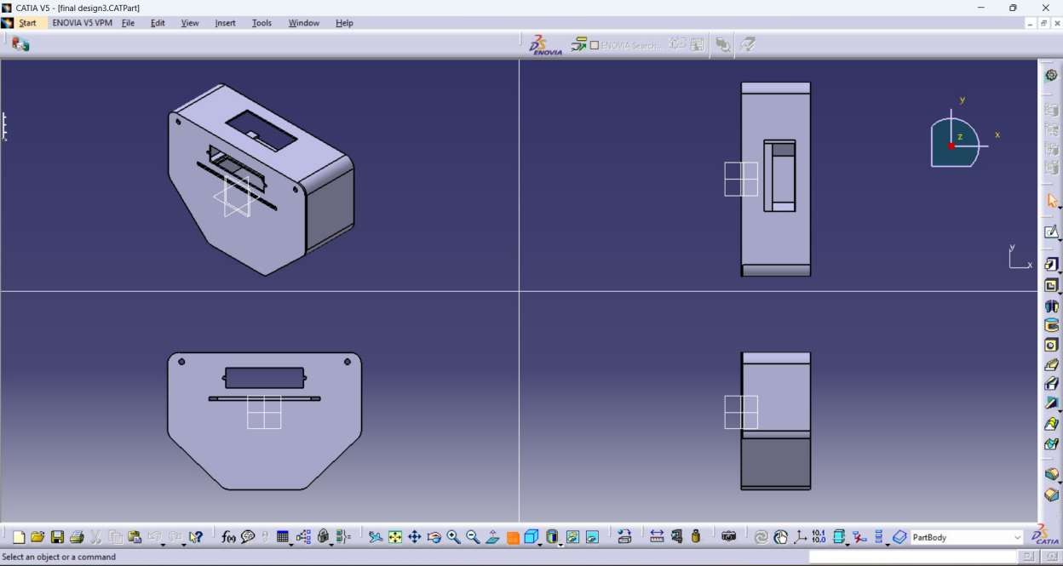
Figure 4.2 Different Views of CAD Model of HexaBot

- Simulation Screenshots
  - Motor driver test signals
  - Sensor range simulation
  - Navigation path visualization
  - Suction performance graph (if any)

- Prototype Development Photos
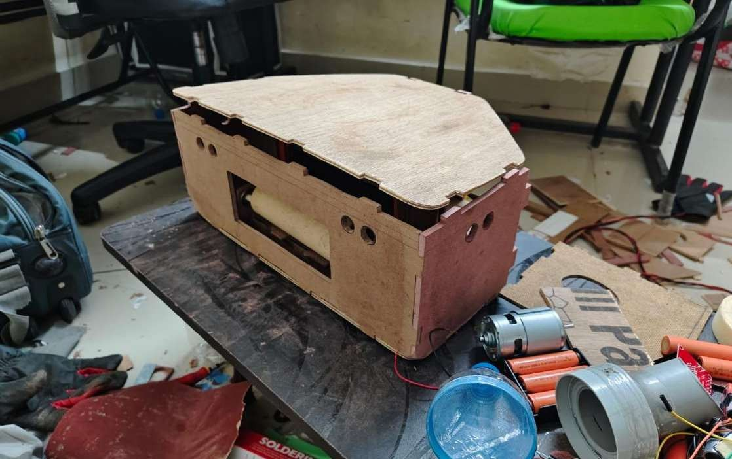
Figure 5.1 Fully assembled body of hexabot

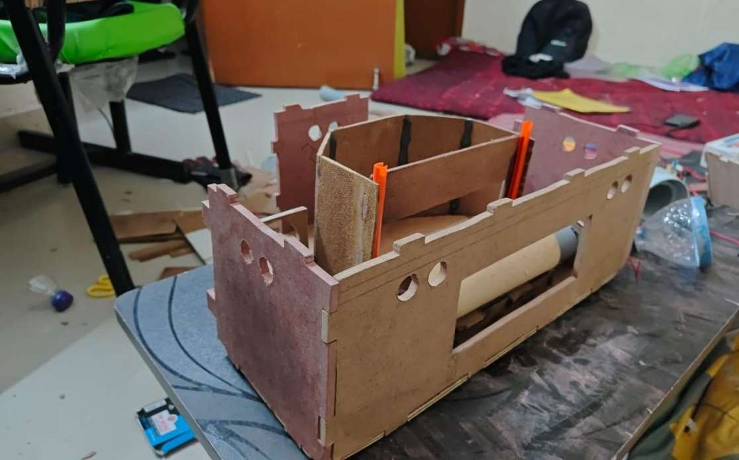
Figure 5.2 Side shot semi assembled body of hexabot (waste bin is visible)

Department of E&TC Engineering DEC-2025 P a g e | 47

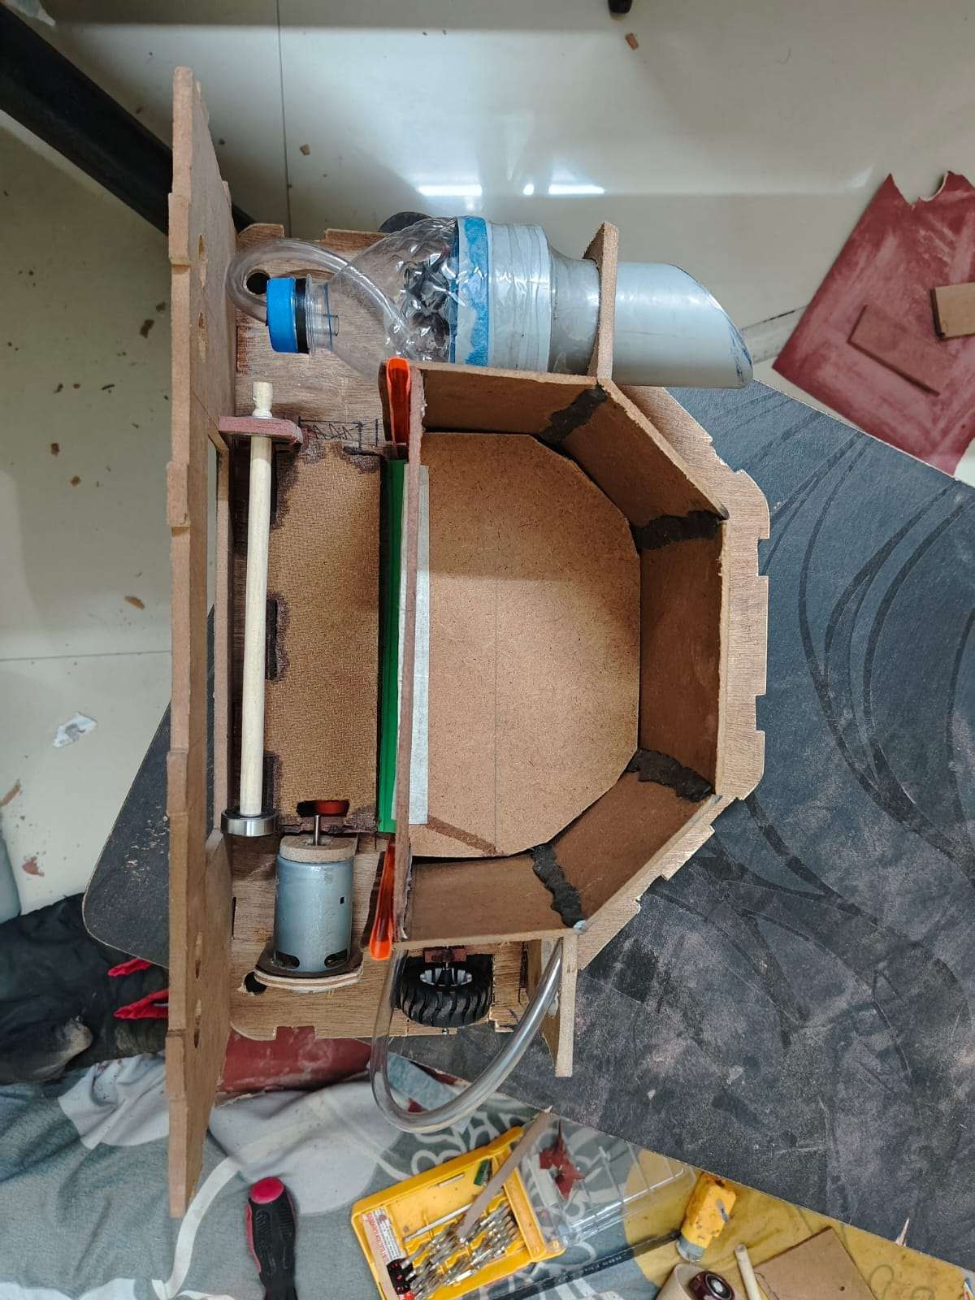
Figure 6.1 Top view of Hexabot

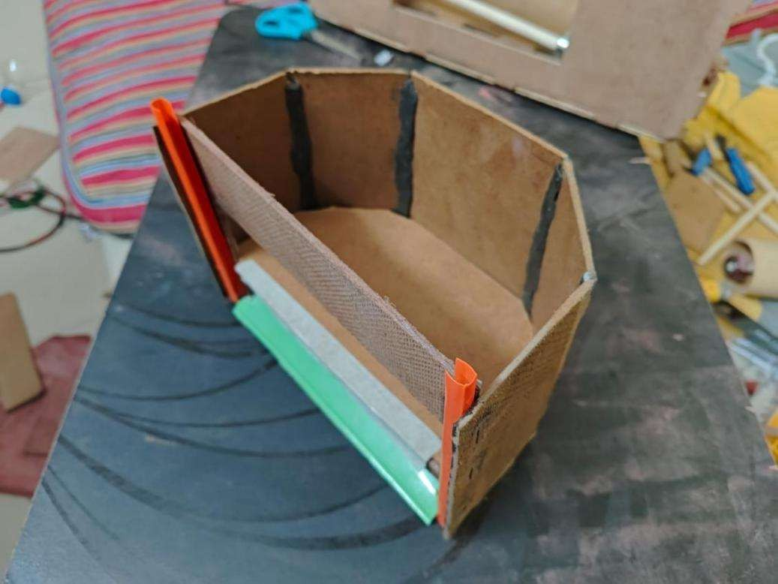
Figure 6.2 Detachable waste bin of Hexabot

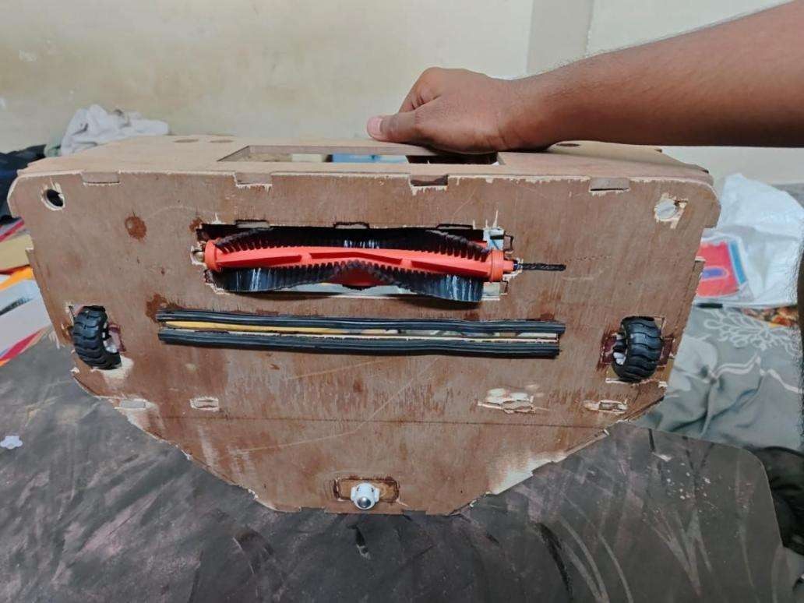
Figure 6.3 Bottom view of Hexabot

